Quality Planning
- Definition
- Grade
- Statistics
  - Control limits
  - Normal Distribution
  - Standard deviation
- Quality Planning Tools
  - Measurement terminology
    - Tolerances
  - Defining and meeting client expectations
- Quality Assurance

Definition of Quality
- Understand the quality levels expected
- Ensure that the levels are met
  - This includes measuring

Grades as a measure of quality
Pre-set standards
- Octane rating for gasoline
- Lumber graded for appearance, strength
- Steel and other commodities

Using statistics to measure and manage quality
- Control limits
  - Upper and lower standards for allowable variation
- Central limit theorem
  - Frequency distribution
  - Discrete math— “bins” –count the number of measurements that fall in each bin
  - Normal distribution– “bell-shaped curve”

Measuring your products
Options:
- Measure entire population
- Sampling
  - A smaller amount of data to work with
  - Sometimes measuring destroys the sample

Normal Distribution
- Standard deviation
  - Calculate the mean (or average value) of all measurements
  - Subtract EACH measurement from the mean
  - Square EACH difference
  - Sum the values
  - Divide the sum by ( (number of values) – 1 )
  - Take the square root
- The result can be thought of as the average difference

Sigma Levels

Quality Plan
- The quality plan specifies the control limits
- Often written as the mean ± the acceptable variation
- The size of the range is called the tolerance

Quality planning techniques
- Cost-benefit analysis
- Benchmarking
- Experimentation design
- Cost of Quality
- Control Charts
- Cause and Effect diagrams
- Histograms
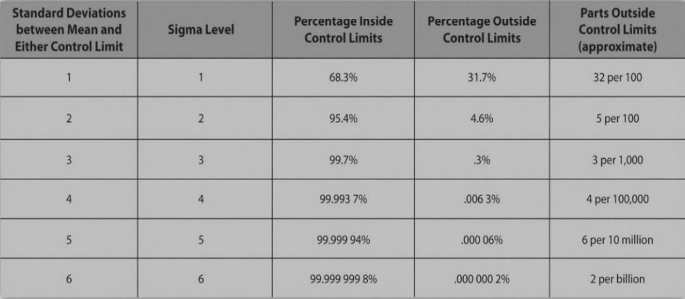
  - Pareto diagram

Quality Assurance
- Process Analysis
  - ISO 9000 requires this

Summary
- Purpose of Quality Management:
  - Build confidence in clients that quality standards and procedures are being followed
- Ensured by
  - Internal review of the plan
  - Testing
  - Revising policies
  - External Review or audit

